**CREATING A YOUTUBE THUMBNAIL WITH CANVA**

Project report templates

1.INTRODUCTION

* With Canva’s YouTube thumbnail templates, you can make click-worthy content your viewers can’t resist watching! Our template library is chock-full of ready-made YouTube thumbnails you can choose from. You can easily customize these templates to fit your channel’s niche.

1.1.OVERVIEW

* With Canva you can enrich your chosen snapshot with text and design elements, or create a clean cut thumbnail design for a synchronized playlist or channel

1.2.PURPOSE

* Your YouTube thumbnail is the first thing your audience sees before watching your video. And with Canva, you can keep your creativity flowing and invite team members to collaborate on your YouTube thumbnail in real-time.

2.PROBLEM DEFENITION &DESIGN THINKING

2.1.Empathy map

* One of the biggest pitfalls of empathy mapping is relying on assumptions, stereotypes, or personal opinions instead of real data. If you don’t have enough research to back up your empathy map, you risk creating a distorted or inaccurate picture of your users

2.2.Brainstorming

* Group dynamics and power dynamics lead people to hold back. A large quantity of ideas does not mean quality of ideas. Brainstorm sessions often have little follow-through because the point is usually to involve the team rather than solve the problem.

EMPATHY MAP

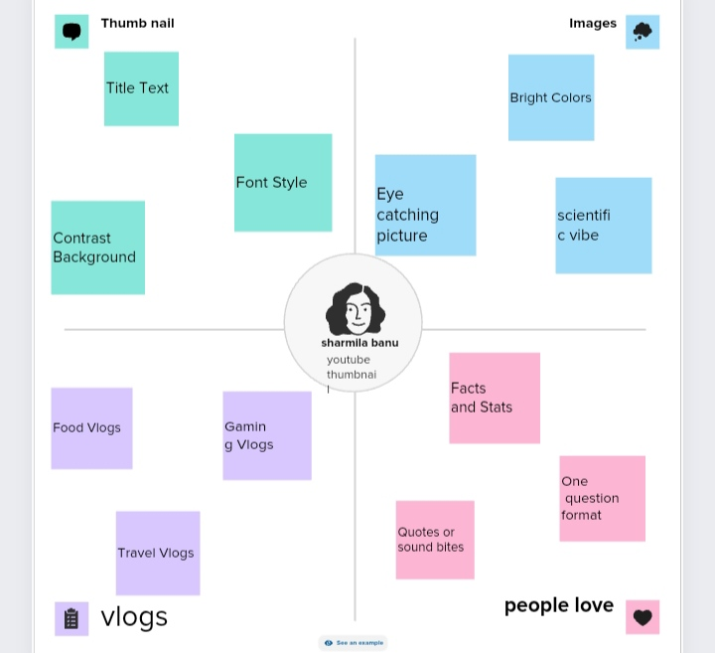

BRAINSTROMING

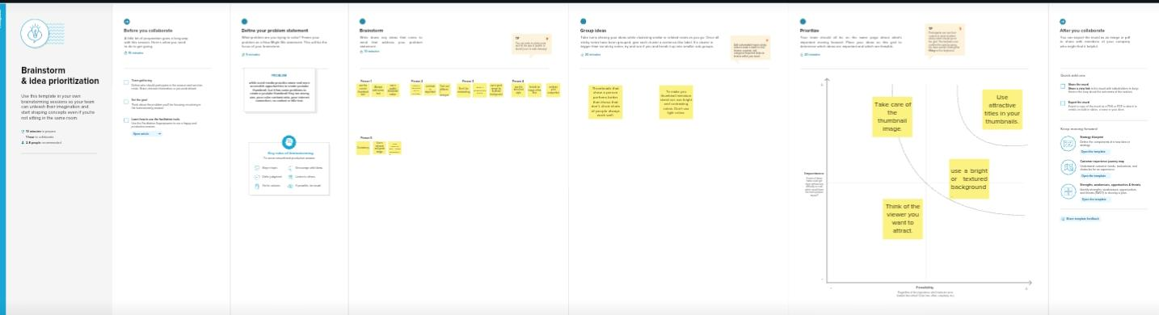

ADVANTAGES

* One of the benefits of using Canva for YouTube thumbnails is that it provides access to a vast library of stock images and graphics that you can use in your design.
* This feature can save you time and effort in sourcing relevant and high-quality images for your thumbnail.

DISADVANTAGES

* One of the main disadvantages of Canva is that it can limit creativity.
* The platform operates on a drag-and-drop basis, which makes it easy to use but can also restrict the level of customization and originality in the designs.

RESULT

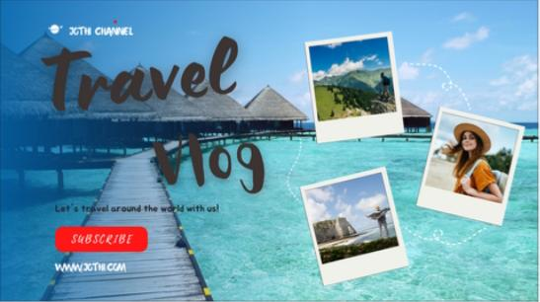

APPLICATION

* Open up Canva and search for the “YouTube Thumbnail” design type to get started.
* Explore templates.
* Enjoy a range of features.
* Canva’s library has millions of photos, icons and illustrations to choose from.
* Customize your thumbnail.
* Get creative with your thumbnail.
* Upload and publish.

CONCLUSION

* Canva app is very useful for different kinds of editing. This make one who expert in editing. Through canva, we can learn to edit, choose color, and make different projects.